# Installation Guide

Firstly you have to attach the database ‘PHOTOLIO’ to your Microsoft SQL Server. And create database ‘PHOTOLIO’ then create tables [dbo].[Category], [dbo].[ContactUs], [dbo].[Order], [dbo].[Position], [dbo].[Product], [dbo].[User].

After finish attach the database you have to open PHOTOLIO web application PHOTILIO.sln file with Microsoft Visual Studio and in the web.config file as shown in figure below

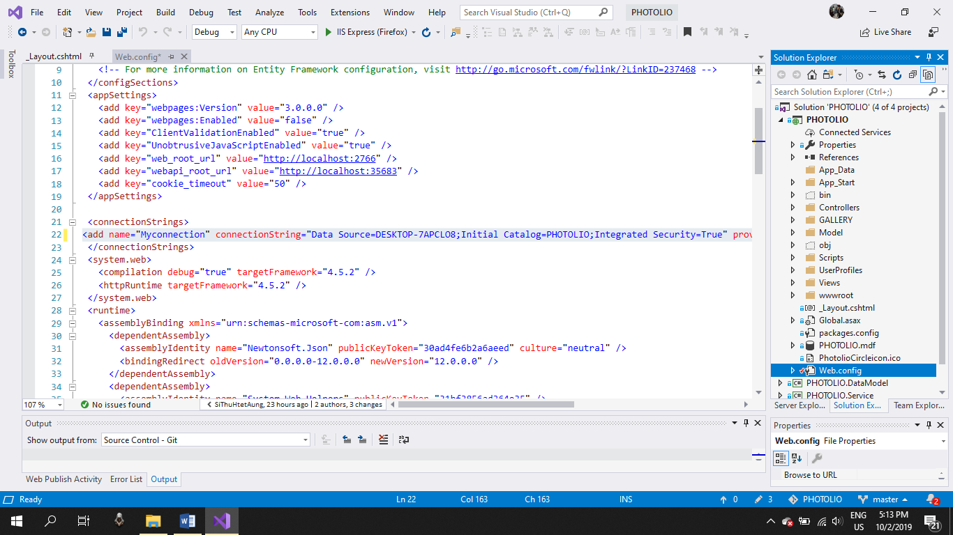

And change the database file path as shown in figure below

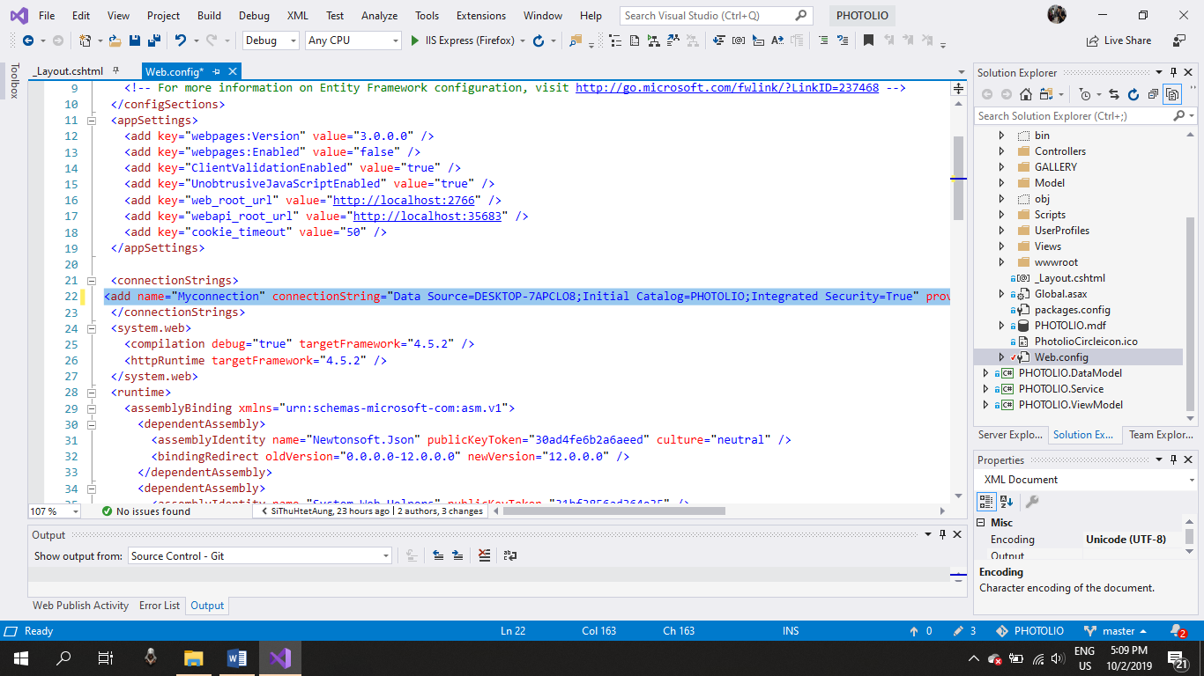

And open the SOLUTION file>PHOTOLIO>Views>Shared>_Layout.cshtml step by step are as shown in figures below

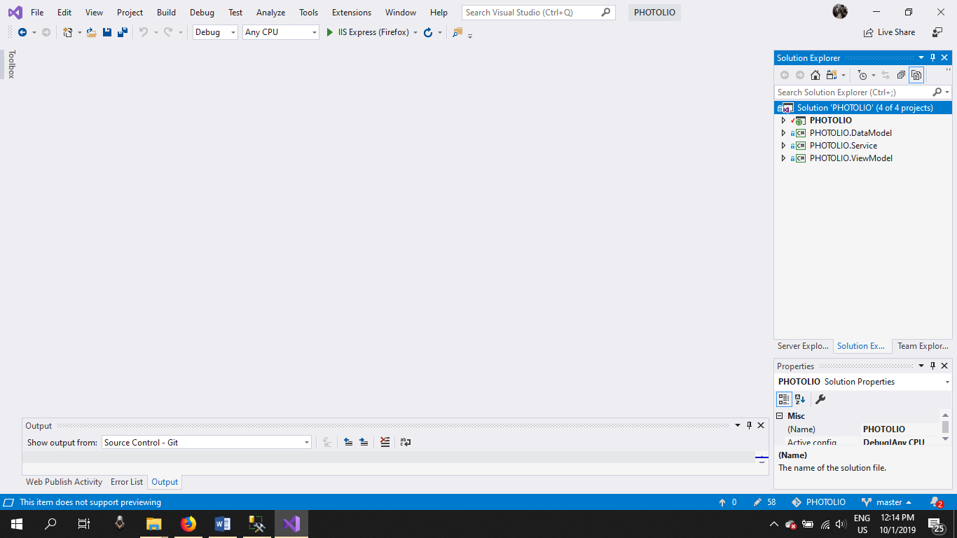 Fig. 1 Open the Solution PHOTOLIO project file

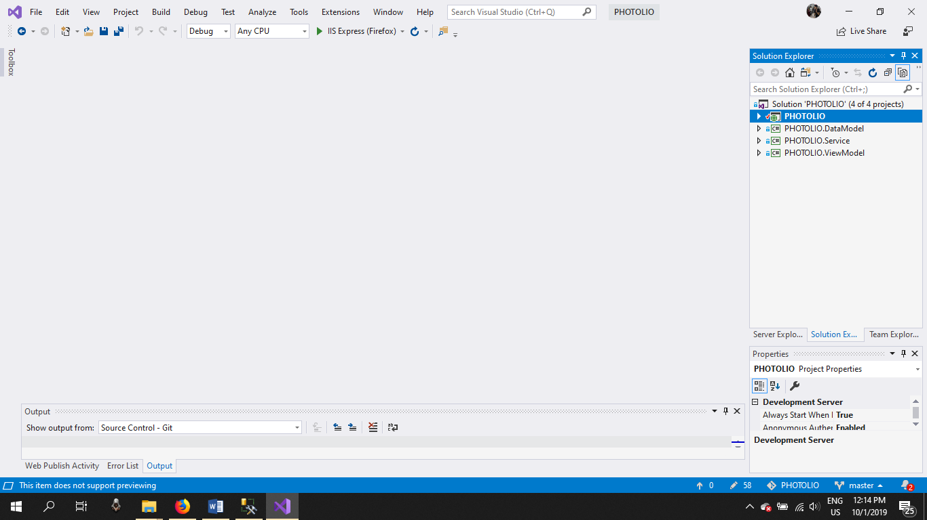 Fig. 2 Open the PHOTOLIO project file

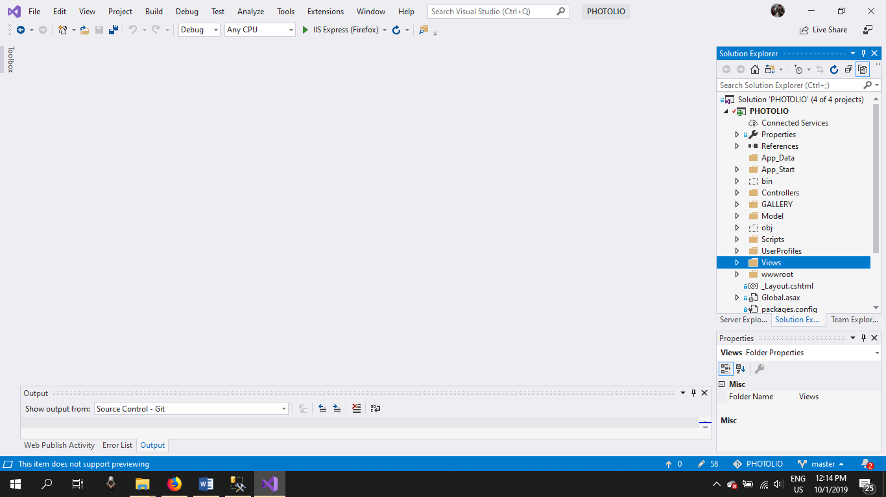 Fig. 3 Open Views folder

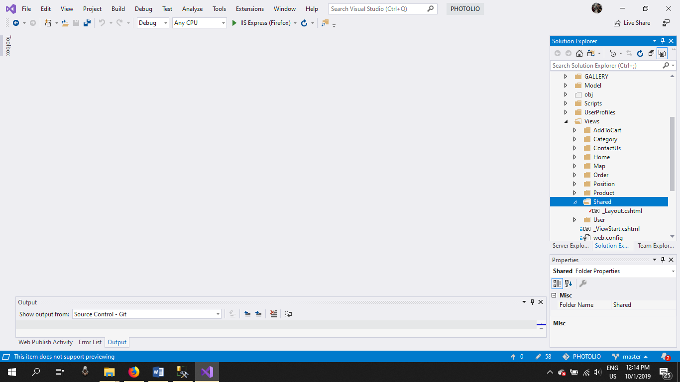 Fig. 4 Open the Shared folder

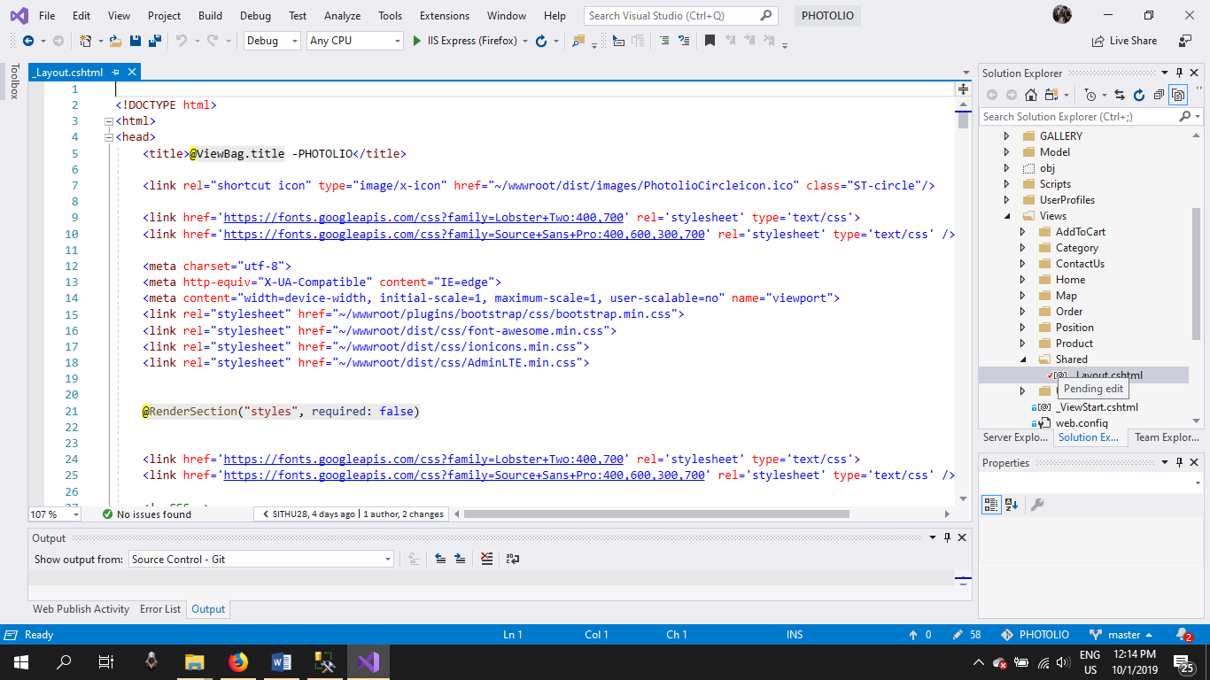

Fig. 5 Tab double click the _Layout.cshtml file

In this website you can test as admin and user if you want to Login as admin your user email is ‘admin@gmail.com’ and your password is ‘admin’ if you want to login as photographer your user email is ‘sithu@gmail.com’ and your password is ‘1111’ or if you want to login as your own account you can signup.

If you login as admin you can see like that

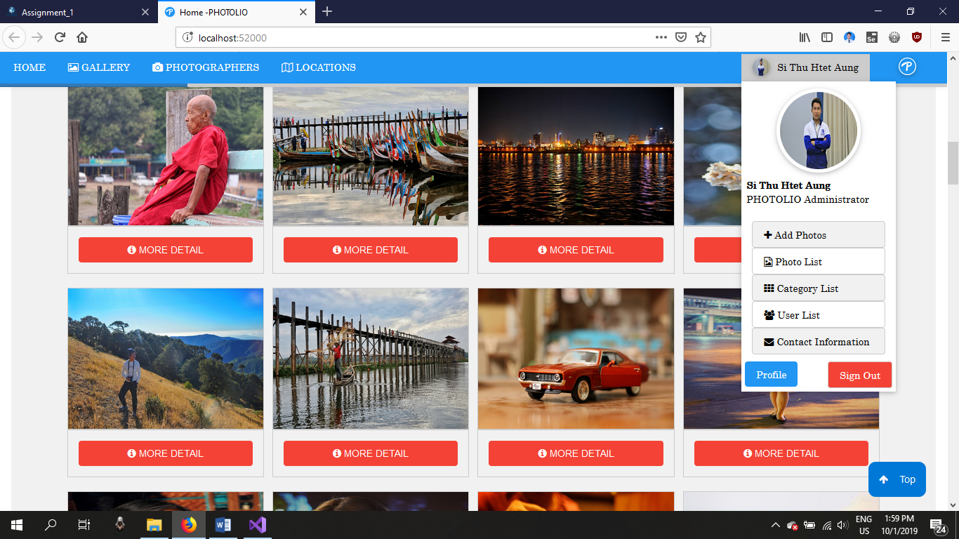

You can check everything in my web site like you can add photos, you can check photo list, you can check category list, you can check user list, and you can check contact list. In Add photo form you can add you creation photos the photo form is as shown in figure below

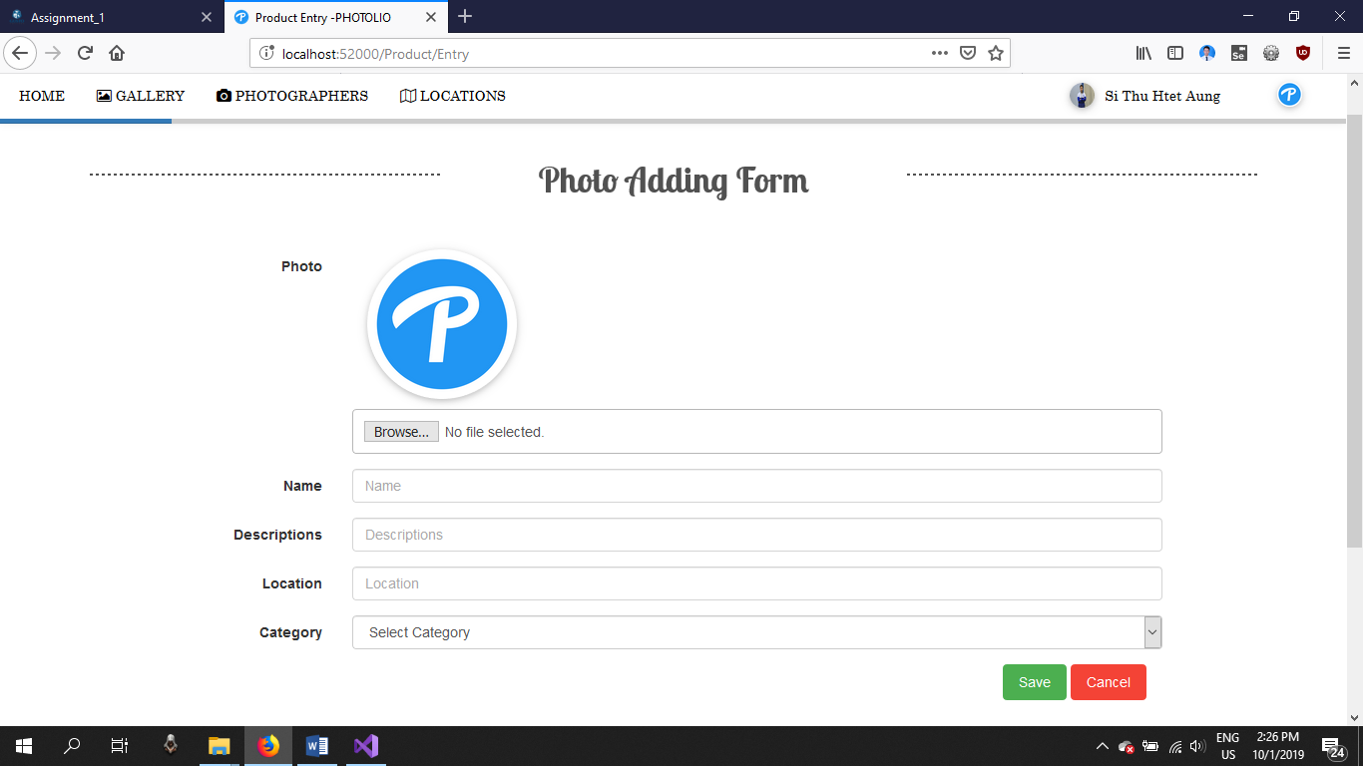

In photo list you can manage photos like edit about photo and you can delete as shown in figure below

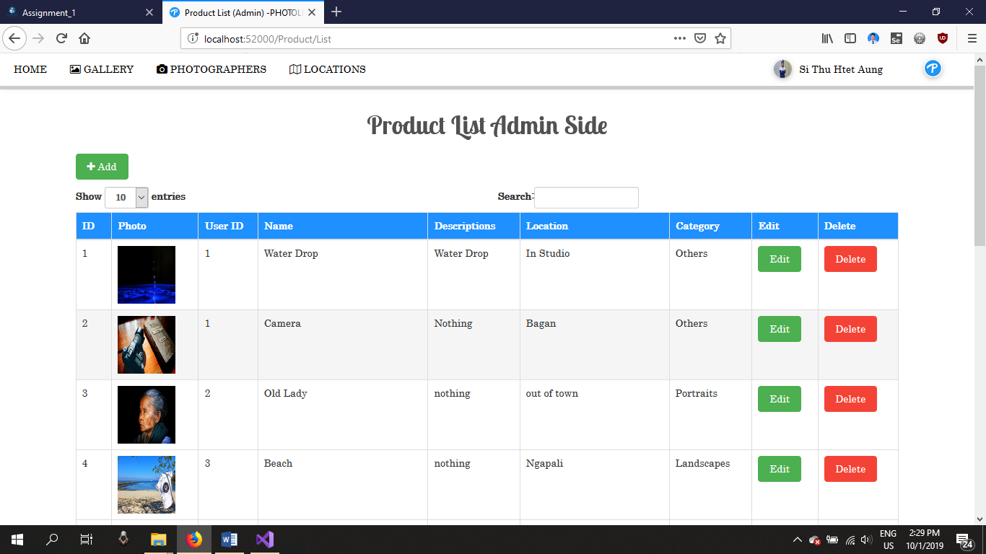

In category list you can manage category like edit about category, you can delete and you can add category as shown in figure below

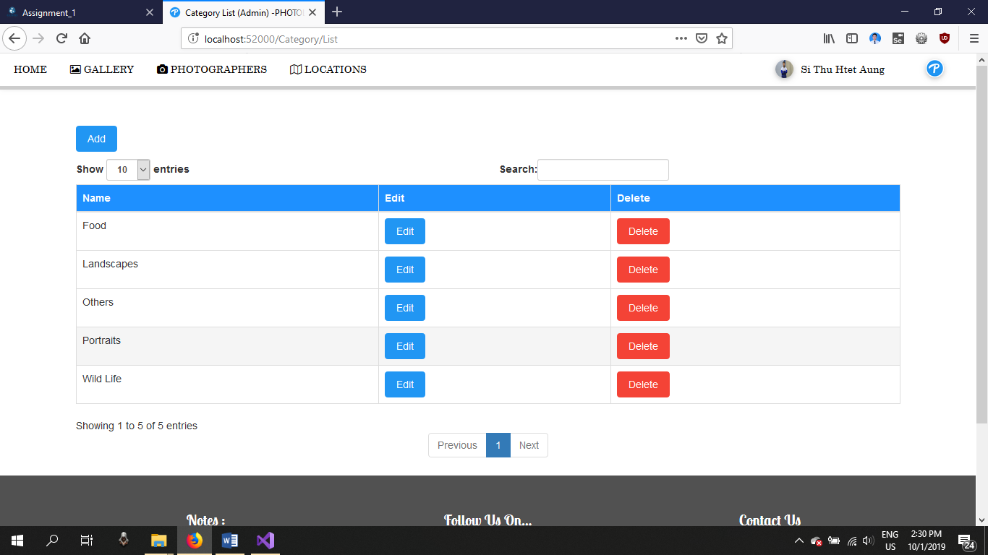

In user list you can manage user like edit about category and you can delete as shown in figure below



In user list you can manage user like edit about category and you can delete as shown in figure below

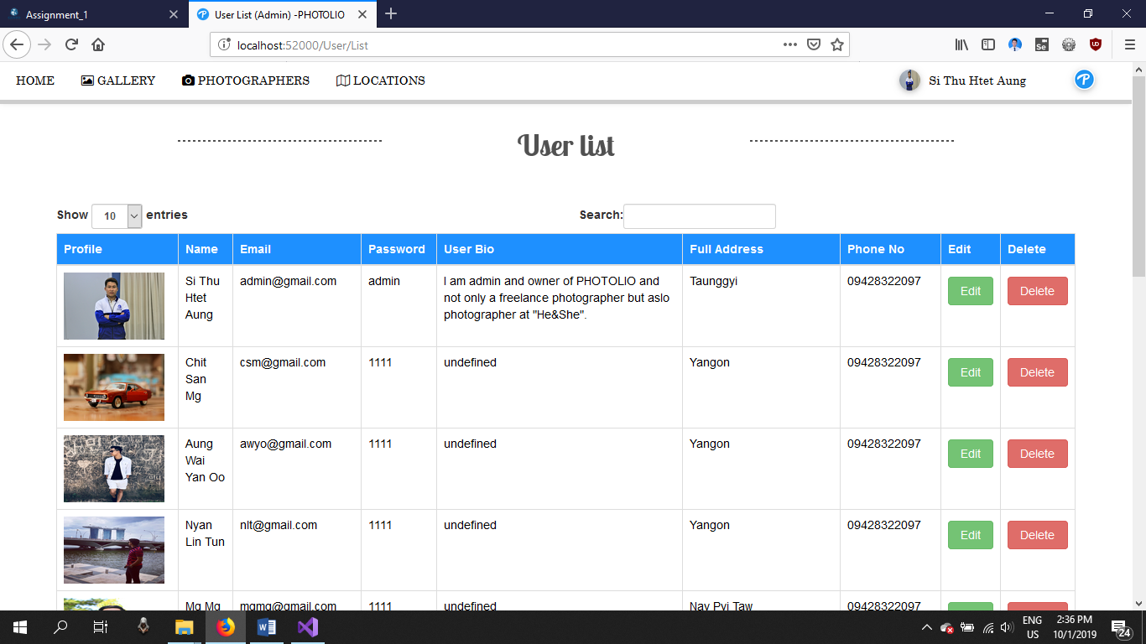

In contact information list you can read contact and you can delete as shown in figure below

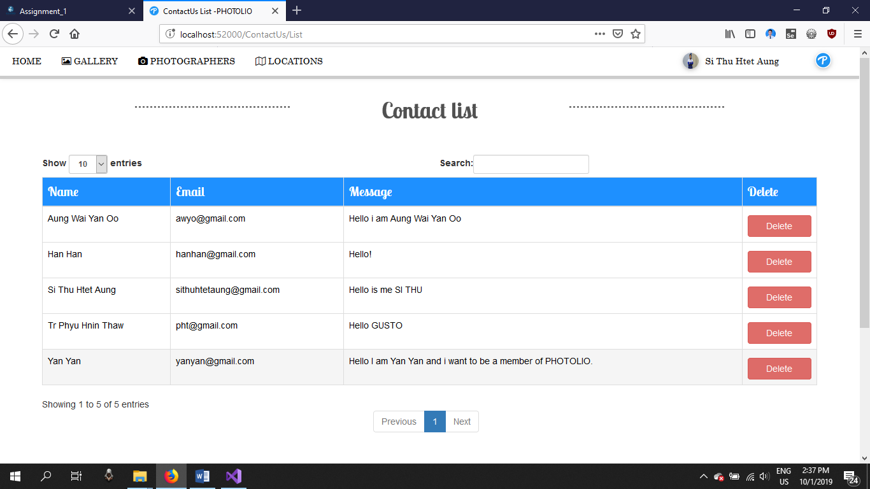

In user (Photographer) you can only post your creation photos you can’t edit or delete because I have no time to create this function for user but my new version will be include this function. But you can edit your profile

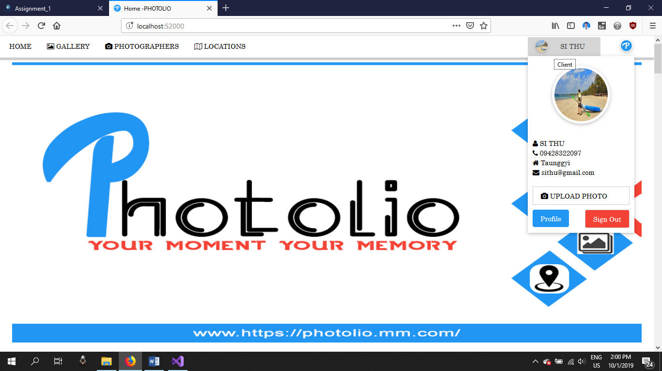

My web footer is include about us form and also contact us form you can see all about my web in about us form and contact form is for our web user.